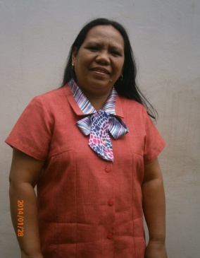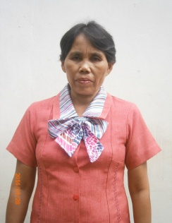

**NORELYN U. MUGATAR**

Grade V-A

**SALVACION F. PAGRAN**

Grade V-B

**ENGELYN T. OGAWA**

Grade IV – Dove

**KRISTINE JOY B. GONZALES**

Grade IV – Panda

**LEO T. FERANDO**

Grade III – Blue

**NEMIA N. PANGANIBAN**

Grade II – Atis

**SHELLA S. BALDADO**

Grade III – Red

**NELIE BENG DEE T. GICANA**

Grade I– Rose

**MA. LUNA P. MAGUAD**

Grade VI

**LETECIA A. FERNIN**

TIC/Subject Teacher

**TERESITA E. GONZALES**

Grade I – Santan

INAPOY ES SCHOOL ORGANIZATIONAL STRUCTURE